Fine Tuning Hand Performance
Optimising functional capacity and injury management in musicians and others
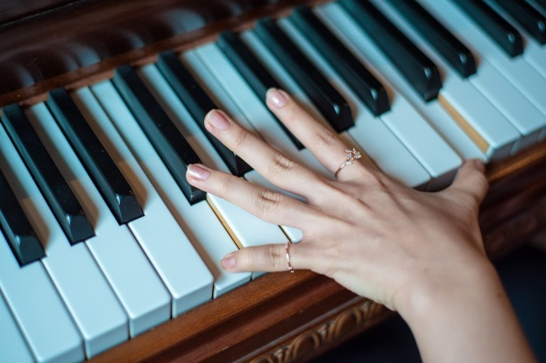
Wellington, NZ, West Plaza Hotel, 110 Wakefield St
Friday and Saturday May 12-13th 2017
A 2 day in depth course looking at musicians hand demands, useful assessment techniques, in- depth instrumental hand issues and treatment techniques.
Presenter: Dr Bronwen Ackerman
Dr Bronwen Ackerman developed her interest in performing arts health in the 1990s. She has worked with the Sydney Symphony Orchestra since 1995. She has a special interest in treating the musician and completed her PhD in 2003 looking at performance related musculoskeletal injuries in violinists. She continues her research into performance related injury management and prevention, optimising performance, and understanding the anatomical and physiological mechanisms underpinning musical performance.
She is consultant Physiotherapist to the New Zealand Symphony Orchestra.
Dr Bronwen Ackerman currently works at the Sydney Medical School, teaching functional musculoskeletal anatomy.
____________________________________
“I’ll come!” - Eileen Carroll MNZAHT IFSHT rep
“Bronwen has been inspirational in giving me practical treatment suggestions that I have used in my practice for years. These treatment strategies have been useful for patients with a wide variety of clinical conditions. I am excited about the opportunity to come to her in depth course, especially after listening to her workshop at the recent AHTA workshop in Sydney” - Anne Wajon PhD, CHT, President IFSHT
_____________________________________

Fine tuning Hand Performance Course details
This course will run over 2 full days
Morning tea, afternoon tea and lunch provided
Course places are limited, so prompt registration is recommended. Registrations will be opened up to non NZAHT physiotherapists and occupational therapists if places are still available from 1 March 2017
The NZAHT website is down for a rebuild at present, so we are unable to have bookings through the website at this time. Registration and payment methods are outlined below.

Accommodation
A limited number of rooms are available at West Plaza hotel at a special conference rate. Please contact West Plaza directly with code #405754
Other accommodation within walking distance:
Amora Hotel, 170 Wakefield St
Youth Hostel YHA, 292 Wakefield St
CQ Comfort Hotel, 213-223 Cuba St
Bay Plaza Hotel, 40 Oriental Parade

The course venue is within walking distance of the CBD shops, in particular funky Cuba St, with restaurants, bars and little shops, and Te Papa national museum.
On Friday and Saturday there are night food markets on Left Bank & Cuba St.

Fine Tuning Hand Performance
Registration and Payment details
Please print, fill in, and return this page, scan and email to ann@wellhand.co.nz

Surname First name

Email address

Cell-phone
Any special dietary requirements-
Member of: (please tick)
NZAHT AHTA

Registration fee
Early bird and member: $NZ 350 (deadline 31 March 2017)
Non-member/ late payment: $NZ 400 after 31 March 2017
Payment:
New Zealand registrants: Internet banking to NZ Assoc Hand Therapists
03 0173 0348961 00 ( Include your SURNAME and MUSIC as reference)
Australian/ overseas registrants:
Register to reserve your place. Payment options for online payment will be available via the NZAHT website in February 2017, www.nzaht.org.nz

Cancellation Policy
Registrant cancellation- Must be in writing. May cancel up to 7 days prior to course minus a $50 admin fee. No refund after this time.
NZAHT will provide full refund of the registration fee only(ie not airfares nor accommodation), if the course is cancelled, or minimum numbers are not met

